HIRING A DAY LA BO RER ? . . . HERE' S YOUR GUIDE T O

BEST PRACTICES FOR HEALTH AND SAFETY

Protect Workers from COVID-19
Make sure workers are able to distance, wash their hands, etc. Provide face coverings for workers and ensure others they interact with wear them as well. Do not expose workers to people or locations that put them at risk. Inform workers immediately if they may have been exposed. See: https://www.dir.ca.gov/dosh/coronavirus/ETS.html

Provide Meal & Rest Breaks
Workers must receive a paid 10-minute rest break for every 4 hours of work, and an unpaid meal break of at least 30 minutes if they work 5 hours or more. (Employer and workers can mutually agree to skip meal breaks if the workday is 6 hours or less.) See: https://www.dir.ca.gov/dlse/LawsTimeMannerPaymentWages.pdf

Set Clear Expectations for the Job
Provide clear communication and expectations about the job from the beginning. Do not ask workers to do work they are not qualified or trained to do.

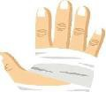
Prevent Injuries & Care for Injured Workers
You are responsible for preventing injuries and illnesses. If they occur, provide access to emergency medical care and coverage through workers' compensation or your homeowner’ insurance.
See: https://www.dir.ca.gov/dwc/employer.htm

Contact our day labor center with any questions, problems, or help with interpretation.

Protect Workers from Environmental Conditions

Provide extra breaks, cool potable water, shade, and training when weather is warm. If workers are exposed to dust, smoke or ash, provide N95 respirator masks. In noisy environments, provide hearing protection. For heat sickness prevention.
Visit: https://99calor.org/english.html

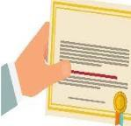
Get Required Construction & Other Types of Licenses
If the cost of construction or renovation is $500 or more, you may need a contractor's license, unless you are an owner-builder. All employers need workers' compensation insurance.
See: https://www.dir.ca.gov/dwc/dwc_home_page.htm

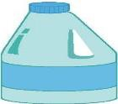
Protect Workers from Chemicals
Use non-toxic products when possible. Provide training on safe use, proper labels on containers and SDSs as well as adequate ventilation and protective gear, such as goggles and gloves.
Provide access to eye washing if necessary.

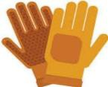
Provide Work Tools& Safety Gear
You are responsible for preventing injuries and illnesses. If they occur, provide access to emergency medical care and coverage through workers' compensation or your homeowners’ insurance.
See: https://www.dir.ca.gov/dwc/employer.htm

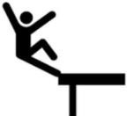
Comply with Cal/OSHA Standards for All Protection
Falls from as low as 5 feet can cause serious injuries or death. For most work 7.5 feet off the ground or higher, fall protection is required. See: https://www.dir.ca.gov/dosh/dosh_publications/Fall-Protection-in-Construction-fs.pdf

This handout was developed by LOHP, UC Berkeley. These materials are part of the Worker Occupational Safety and Health Training and Education Program (WOSHTEP) administered by the Commission on Health and Safety and Workers Compensation in the California Department of Industrial Relations through interagency agreements with the Labor Occupational Health Program at the University of California, Berkeley; the Western Center for Agricultural Health and Safety at the University of California, Davis; and the Labor Occupational Safety and Health Program at the University of California, Los Angeles.
Center Name Tel No.
Email

Updated 10 2021 Laws referenced are for California

